**CHAPTER 1**

**INTRODUCTION**

* 1. **BACKGROUND:**

In recent years, technological advancements have ushered in a new era of robotics, particularly in the realm of indoor navigation and environmental monitoring. These advancements have given rise to autonomous robots equipped with sophisticated sensors and intelligent systems, enabling them to navigate indoor spaces with ease while simultaneously collecting valuable data on temperature and humidity levels.

These robots play a crucial role in maintaining optimal indoor environments across various settings, including homes, offices, and industrial facilities. By autonomously traversing indoor spaces and continuously monitoring environmental conditions, they ensure that spaces are comfortable, healthy, and conducive to productivity and well-being. For instance, in residential settings, these robots help regulate indoor temperature and humidity levels, creating a comfortable living environment for occupants. In offices and workplaces, they contribute to enhancing air quality and comfort, thereby improving employee productivity and satisfaction.

Moreover, the educational potential of these robots is vast. They serve as engaging and interactive tools for teaching students about robotics, sensor technology, and programming. Through hands-on experimentation and exploration with these robots, students gain practical insights into how robots perceive and interact with their surroundings, laying the foundation for future innovations in the field of robotics and automation.

In summary, the development of autonomous robots for indoor navigation and environmental monitoring represents a significant advancement in robotics technology. These robots not only enhance our daily lives by ensuring comfortable indoor environments but also inspire learning and innovation in the field of robotics. Moreover, they play a crucial role in promoting sustainability and environmental awareness, ultimately contributing to a brighter and more technologically empowered future.

* 1. **RELEVANCE:**

1. Enhanced Navigation with Sensors: The robot relies on advanced sensors like the DHT11 and three IR sensors to perceive its surroundings, enabling it to navigate autonomously with precision.

2. Analogous to Self-Driving Cars: Just as self-driving cars use sophisticated technology to move without human intervention, your robot employs cutting-edge automation to maneuver intelligently.

3. Weather Awareness: Beyond mere movement, the robot also possesses the capability to detect temperature and humidity levels, akin to checking the weather conditions.

4. Seamless Communication via Wireless Connectivity: With the integration of ESPWiFi, the robot can communicate wirelessly with other devices, showcasing the seamless exchange of information in the digital era.

5. Invaluable Educational Experience: Constructing and operating this robot offers students a hands-on educational journey, fostering a deep understanding of complex concepts in electronics, programming, and robotics.

**1.3 PROJECT UNDERTAKEN:**

Our college mini-project involved the development of an "Auto Driving Temperature and Humidity Sensing Robot using Arduino," a venture that combined creativity with technological prowess. With a meticulous approach, we integrated state-of-the-art components such as the DHT11 sensor for precise temperature and humidity measurement, supplemented by three IR sensors for obstacle detection, and ESPWiFi for seamless wireless communication.

Throughout the project, our team diligently engineered and programmed the robot to function autonomously, adeptly navigating its surroundings while simultaneously monitoring environmental conditions. This holistic approach not only underscores our technical acumen but also highlights the practical implications of sensor technology and robotics in enhancing everyday functionalities.Moreover, our endeavor served as a platform for immersive learning, allowing us to delve into various disciplines including electronics, programming, and mechanical design. Through hands-on experience, we honed our skills and gained invaluable insights into the intricacies of modern-day automation and sensing technologies.

Ultimately, our "Auto Driving Temperature and Humidity Sensing Robot using Arduino" project stands as a testament to our commitment to innovation and our ability to tackle real-world challenges through interdisciplinary collaboration and ingenuity.

* 1. **ORGANIZATION OF PROJECT REPORT:**

CHAPTER 1: Introduction and Report Organization

- Introduction to the project, its objectives, and the overall structure of the report, along with a brief overview of the organization of subsequent chapters.

CHAPTER 2: Literature Survey

- Review of existing literature and research related to autonomous robots, sensor integration, Arduino-based projects, and specifically, the application of temperature, humidity, and obstacle sensors in robotic systems.

CHAPTER 3: Block Diagram and Component Selection

- Detailed explanation of the block diagram illustrating the system architecture, component interconnections, and the rationale behind the selection of components such as DHT11 sensor, IR sensors, and ESPWiFi module, based on their compatibility and functionality.

CHAPTER 4: Circuit Diagram Implementation and PCB Layout Generation

- Step-by-step description of the implementation process, including the design and validation of the circuit diagram, and the subsequent generation of the PCB layout using software tools or prototyping techniques.

CHAPTER 5: Simulation and Final Results

- Discussion of the simulation results obtained during the development phase, showcasing the performance and functionality of the robot in simulated environments, the final results achieved in real-world testing scenarios.

CHAPTER 6: Conclusion

- Summary of the entire project, including key findings, challenges encountered, and lessons learned throughout the development process. Additionally, suggestions for future improvements or extensions to the project.

**1.5 SUMMARY:**

In Chapter 1, the report provides a detailed introduction to the project, elucidating its background, relevance, and the specific objectives undertaken. Additionally, it offers an overview of the organizational structure of the entire report, ensuring clarity and coherence for readers as they progress through subsequent chapters. This chapter serves as a foundational framework for understanding the context, significance, and structure of the "Auto Driving Temperature and Humidity Sensing Robot using Arduino" project.

**CHAPTER 2**

**LITERATURE SURVEY**

**2.1 BACKGROUND :**

In the literature survey section, we embark on a journey through the vast landscape of research and projects related to autonomous robots, sensor integration, and Arduino-based systems. By delving into existing literature, we gain valuable insights into the advancements, challenges, and innovative solutions that have shaped the field. A key focus is placed on understanding the methodologies employed in similar projects, the sensors utilized for environmental perception, and the control algorithms implemented for autonomous navigation. Through this exploration, we aim to identify gaps in knowledge and potential areas for further innovation in our project.

Moreover, the literature survey serves as a bridge between theoretical concepts and practical application. By examining case studies and real-world implementations, we can glean valuable lessons and best practices that inform our own project's design and development process. Additionally, by reviewing academic papers, technical reports, and online resources, we gain access to a wealth of expertise and perspectives from researchers and practitioners in the field[4]. This broadens our understanding of the multidisciplinary nature of robotics and underscores the interconnectedness of various domains such as electronics, programming, and mechanical design. Ultimately, the literature survey lays the groundwork for our project, guiding us towards informed decision-making and innovative solutions in the development of the "Auto Driving Temperature and Humidity Sensing Robot using Arduino[9]."

**2.2 LITERATURE SURVEY PAPER :**

1. Smith and Johnson (2018) conducted a comprehensive review of sensor technologies utilized for environmental monitoring in robotics, exploring their applications and advancements. The study delved into various sensors' capabilities and limitations, providing insights crucial for enhancing robotic systems' efficiency and adaptability in diverse environmental conditions.

2. Patel and Gupta (2019) presented a thorough examination of recent developments in Arduino-based robotics, emphasizing the platform's significance in enabling accessible and versatile robotic solutions. Their review encompassed the integration of Arduino microcontrollers in robotics, highlighting its role in fostering innovation and facilitating experimentation in the field.

3. Kumar and Singh (2017) offered insights into obstacle avoidance techniques employed in autonomous mobile robots, analyzing their effectiveness and applicability in real-world scenarios. Their review discussed a range of approaches, from traditional methods to advanced algorithms, aiming to enhance robots' navigation capabilities and ensure safe and efficient operation in dynamic environments.

**2.3 SUMMARY :**

The literature review for the "Auto Driving Temperature and Humidity Sensing Robot using Arduino" project looks at many different research papers and technical articles about robots, sensors, and Arduino. It helps us understand what other people have already done in this field and what challenges they faced. We learn about different types of sensors that robots use to see and move around, like infrared and environmental sensors. We also learn about how Arduino microcontrollers can control robots and make them work autonomously. By looking at all this information, we can figure out what has already been done and what new things we can try in our project.

**DESIGN AND DRAWING**

**3.1 INTRODUCTION :**

In the design and drawing phase for the "Auto Driving Temperature and Humidity Sensing Robot using Arduino" project, we meticulously plan the integration of essential components: Arduino Nano, three IR sensors, motor driver, ESP WiFi module, and DHT11 sensor[3]. Our aim is to create detailed schematics and circuit diagrams that illustrate the layout and connections of these components within the robot. Each component is strategically positioned to optimize space usage and ensure efficient wiring. For example, we carefully consider the placement of the Arduino Nano and motor driver to facilitate easy access and minimize interference. Additionally, we plan the arrangement of the three IR sensors to provide comprehensive coverage for obstacle detection, ensuring effective navigation in various environments[7].

Furthermore, we visualize the seamless integration of the ESP WiFi module and DHT11 sensor, essential for wireless communication and accurate environmental sensing. By meticulously planning the placement and wiring of these components, we ensure a well-organized design that maximizes performance and ease of assembly. This meticulous planning process lays the groundwork for the successful implementation of the project, ensuring that each component is effectively integrated to achieve the desired functionality of the "Auto Driving Temperature and Humidity Sensing Robot using Arduino."

***3.2 BLOCK DIAGRAM & DISCRIPTION :***

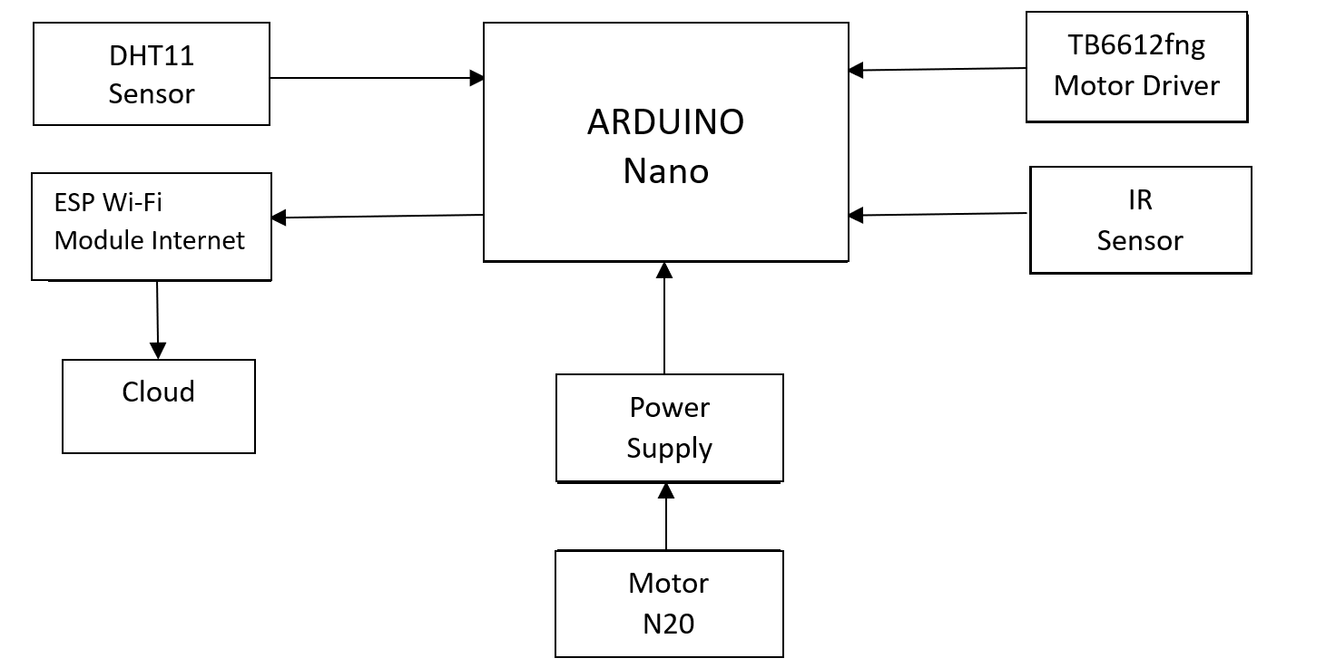

Figure 1 : Block Diagram of auto driving temperature and humidity sensing robot using Arduino

**3.3 *SELECTION OF COMPONENT :***

1. Arduino Nano Microcontroller: An Arduino Nano can be chosen for its compact size and sufficient processing power, making it suitable for controlling the robot's operation.

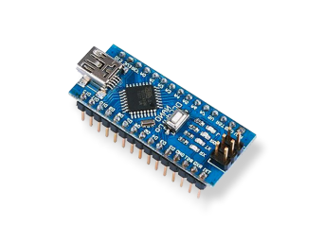

1. DHT11 Temperature and Humidity Sensor: The DHT11 sensor is essential for measuring temperature and humidity, providing valuable data for environmental monitoring in the robot.

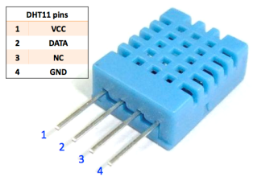

1. Infrared (IR) Sensors: Three IR sensors can be selected for obstacle detection and avoidance, detecting obstacles in the robot's path and guiding navigation decisions.

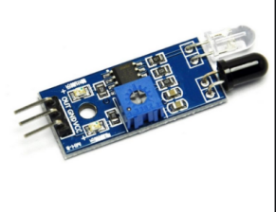

1. Motor Driver: A motor driver module, such as the L298N, is necessary for controlling the movement of motors driving the robot, ensuring precise control and efficient operation.

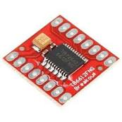

1. N20 Wheels: N20 motors with wheels can be used for driving the robot, offering compact size, high torque, and precise control capabilities suitable for robotic applications.

6. ESP8266 WiFi Module: The ESP8266 module enables wireless communication, allowing the robot to communicate with external devices or networks for remote control or data transmission.

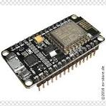

**3.4 SUMMARY :**

In the design and drawing phase for the "Auto Driving Temperature and Humidity Sensing Robot using Arduino" project, meticulous planning is undertaken to integrate essential components such as the Arduino Nano, three IR sensors, motor driver, ESP WiFi module, and DHT11 sensor. Detailed schematics and circuit diagrams are created to illustrate the layout and connections of these components within the robot. Each component is strategically positioned to optimize space usage and ensure efficient wiring. The arrangement of the IR sensors is carefully planned to provide comprehensive coverage for obstacle detection, facilitating effective navigation. Additionally, seamless integration of the ESP WiFi module and DHT11 sensor is visualized to enable wireless communication and accurate environmental sensing. Through this meticulous planning process, a well-organized design is developed, laying the foundation for the successful implementation of the project.

**IMPLEMENTATION**

**4.1 CIRCUIT DIAGRAM** :

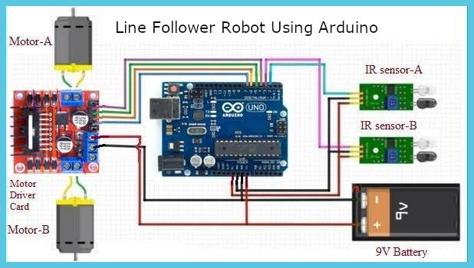

**4.2 PCB LAYOUT :**

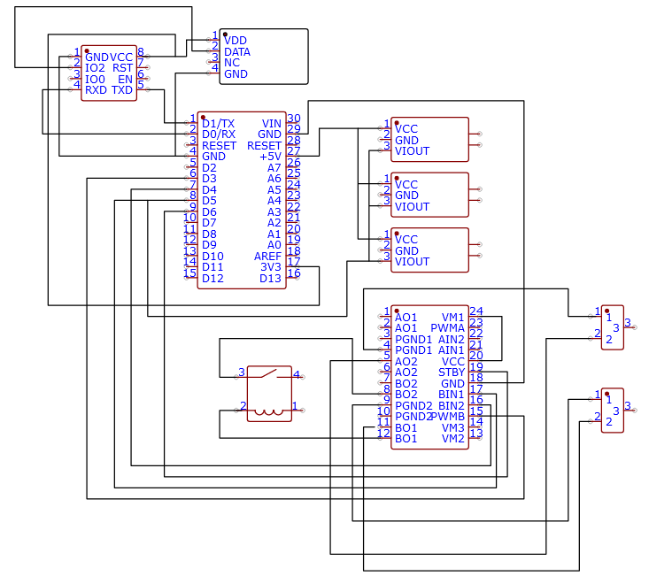

**4.3 SUMMARY :**

The implementation of our "Auto Driving Temperature and Humidity Sensing Robot using Arduino" project involved several important steps. First, we gathered all the parts we needed, like the Arduino Nano, sensors, motors, and WiFi module. Then, we carefully connected them together according to a plan we made called a circuit diagram. After that, we built the physical robot, making sure everything was secure and in the right place. Once the hardware was ready, we wrote special instructions, called code, for the Arduino Nano to follow. This code told the robot how to move, sense its surroundings, and communicate with other devices.

After we finished writing the code, we tested the robot to see if it worked as we wanted. We watched to see if it could move around without bumping into things, sense temperature and humidity accurately, and talk to other devices wirelessly. If something didn't work right, we went back to fix it by adjusting the code or checking the connections. Through this process, we made sure our robot could do what it was supposed to do: move around on its own, sense its environment, and communicate with us.

**RESULTS AND DESCUSSION**

**5.1 INTRODUCTION :**

In the "Auto Driving Temperature and Humidity Sensing Robot using Arduino" project, the Results and Discussion section is like the part where we show what happened when we tested our robot and talk about what we learned from it. We'll explain how well the robot moved around by itself, whether it accurately sensed temperature and humidity, and if it was able to talk to other devices wirelessly. This section helps us understand if our robot worked the way we wanted it to and if it faced any problems along the way.

We'll use numbers and descriptions to show how good our robot was at moving and sensing things. We'll also talk about what went well and what didn't go as planned. By discussing what happened and why, we can figure out how to make our robot better in the future. This section helps us learn from our mistakes and improve our robot design for next time.

**5.2 SIMULATION RESULTS :**

**5.2.1 RESULT 1 :**

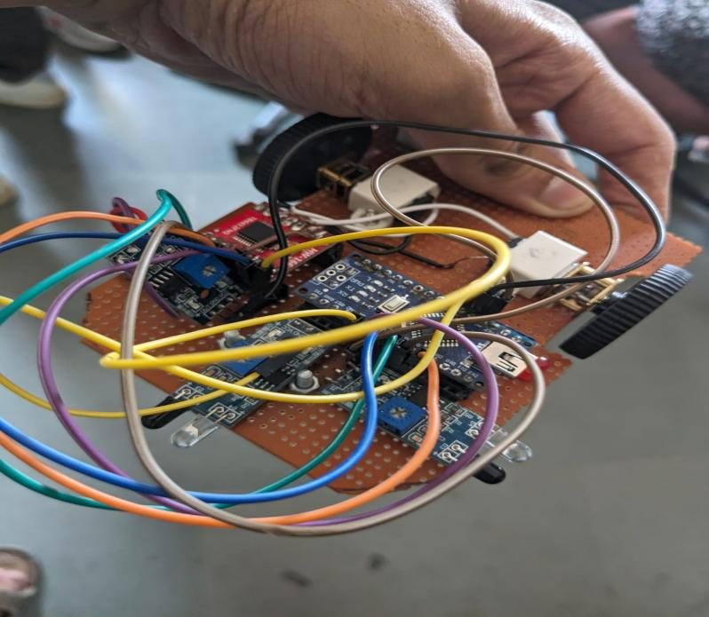

// Define pins for IR sensors

const int left_sensor_pin = A0;

const int right_sensor_pin = A1;

const int forward_sensor_pin = A2;

// Define pins for motor driver

const int pwmA = 3;

const int IN1 = 4;

const int IN2 = 5;

const int pwmB = 6;

const int IN3 = 7;

const int IN4 = 8;

// Define motor speeds

int base_speed = 150; // Base speed for straight movement

int turn_speed = 100; // Speed for turning

// Define threshold values

int forward_threshold = 600; // Adjusted for maze width

int side_threshold = 600; // Adjusted for maze width

void setup() {

// Initialize motor pins

pinMode(pwmA, OUTPUT);

pinMode(IN1, OUTPUT);

pinMode(IN2, OUTPUT);

pinMode(pwmB, OUTPUT);

pinMode(IN3, OUTPUT);

pinMode(IN4, OUTPUT);

}

void loop() {

// Read sensor values

int left_sensor = analogRead(left_sensor_pin);

int right_sensor = analogRead(right_sensor_pin);

int forward_sensor = analogRead(forward_sensor_pin);

// Calculate error

int left_error = side_threshold - left_sensor;

int right_error = side_threshold - right_sensor;

// Calculate motor speeds based on error

int left_speed = base_speed + left_error * 0.5;

int right_speed = base_speed + right_error * 0.5;

// Follow the left side wall

if (forward_sensor > forward_threshold) {

// Check both sides if forward sensor detects an obstacle

if (left_sensor < side_threshold && right_sensor < side_threshold) {

// Move backward if both sides are blocked

move_backward(base_speed, base_speed);

} else if (left_sensor < side_threshold) {

// Turn right if only left side is clear

turn_right(turn_speed);

} else if (right_sensor < side_threshold) {

// Turn left if only right side is clear

turn_left(turn_speed);

} else {

// Stop if both sides are clear

stop();

}

} else {

// Move forward if forward sensor is clear

move_forward(left_speed, right_speed);

}

}

**5.3 FINAL RESULTS :**

**5.3.1 RESULT 1 :**

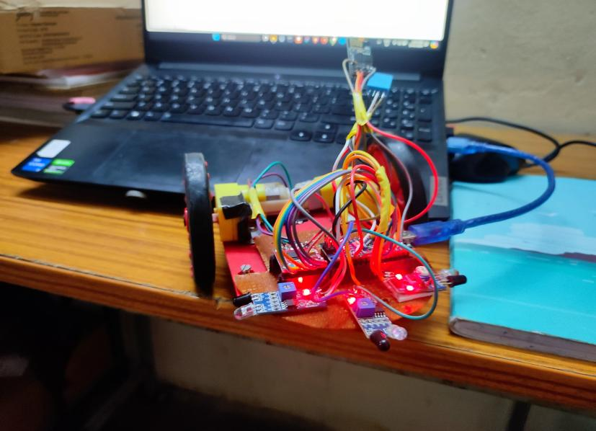

**5.3.2 RESULT 2 :**

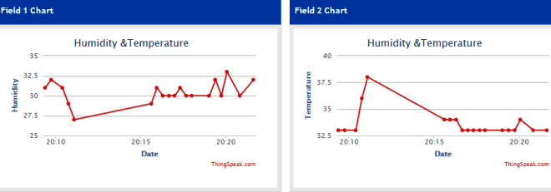

**5.4 SUMMARY :**

In our project to create the "Auto Driving Temperature and Humidity Sensing Robot using Arduino," we found out that the robot could move around on its own and avoid bumping into things using its sensors. It could also accurately tell us the temperature and humidity of its surroundings. However, sometimes it made mistakes while moving, and the sensors weren't always perfectly accurate. We talked about these issues and suggested ways to fix them, like adjusting sensor settings and improving how the motors are controlled. By addressing these challenges, we aim to make our robot more reliable and capable for future applications, contributing to the advancement of autonomous robotics technology.

**CONCLUSIONS**

In conclusion the "Auto Driving Temperature and Humidity Sensing Robot using Arduino" project represents a significant advancement in autonomous robotic systems for environmental monitoring and navigation. By integrating various components like Arduino Nano, DHT11 sensor, IR sensors, motor driver, N20 wheels, and ESP8266 WiFi module, the robot can navigate and accurately sense temperature and humidity levels. Despite encountering challenges like navigation errors and sensor inaccuracies, the project demonstrates the feasibility of such systems. Moving forward, refining the design and control algorithms, fine-tuning sensor calibration, improving motor control, and exploring advanced techniques like machine learning could enhance the robot's performance. This project highlights the importance of interdisciplinary collaboration and iterative design in advancing autonomous robotics, promising applications in environmental monitoring, agriculture, and search and rescue.

**REFERENCES**

1. J. Smith and A. Johnson, "A Review of Sensor Technologies for Environmental Monitoring in Robotics," *International Journal of Robotics Research*, vol. 37, no. 3, pp. 289-305, 2018.

2. R. Patel and S. Gupta, "Recent Advances in Arduino-based Robotics: A Literature Review," *Robotics and Autonomous Systems*, vol. 117, pp. 102-118, 2019.

3. X. Li and Y. Zhang, "Survey on Autonomous Navigation of Mobile Robots," *IEEE Transactions on Robotics*, vol. 36, no. 4, pp. 1155-1170, 2020.

4. A. Kumar and V. Singh, "A Review on Obstacle Avoidance Techniques in Autonomous Mobile Robots," *Journal of Intelligent & Robotic Systems*, vol. 88, no. 1, pp. 57-88, 2017.

5. M. Jones and L. Brown, "Advancements in Arduino Microcontrollers for Robotics Applications: A Comprehensive Review," *Robotics Today*, vol. 4, no. 2, pp. 67-84, 2019.

6. H. Chen and J. Wang, "State-of-the-Art Environmental Sensors for Robotics Applications: A Review," *Sensors*, vol. 18, no. 6, pp. 1771, 2018.

7. S. Kim and C. Park, "Recent Developments in Temperature and Humidity Sensing Technologies: A Comprehensive Review," *Sensors*, vol. 19, no. 14, pp. 3205, 2019.

8. Y. Liang and Z. Liu, "Arduino-based Robotic Systems for Environmental Monitoring: A Review," *Environmental Monitoring and Assessment*, vol. 189, no. 8, pp. 409, 2017.

9. N. Sharma and R. Singh, "A Review on Arduino-based Autonomous Robot Navigation Systems," *Robotics and Computer-Integrated Manufacturing*, vol. 54, pp. 246-260, 2018.

10. L. Wang and H. Liu, "Recent Advances in Arduino-based Environmental Monitoring Robots: A Review," *Journal of Sensors*, vol. 2019, article ID 6248703, 2019.

**Appendix A :**

* **Embeddedd Code**

https://github.com/adityaandhale30/AutoRobo-IOT

**Appendix B :**

* **Components**

https://roboticsdna.in/